1. Python Program to Find LCM
2. Python Program to Make a Simple Calculator

3.Program to Merge Two Lists
4. Demonstrate the difference between list and tuple
5. Try the following on tuple
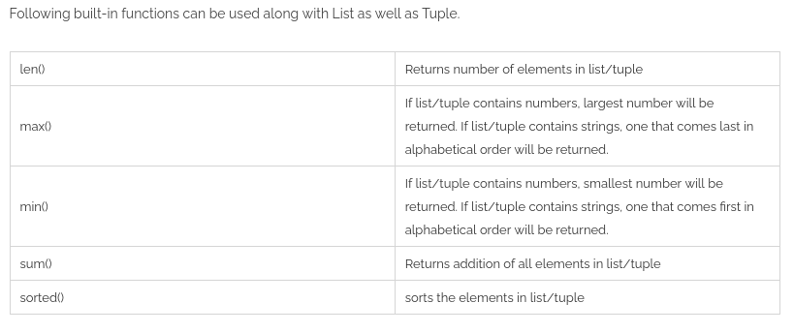
6. Demonstrate the following
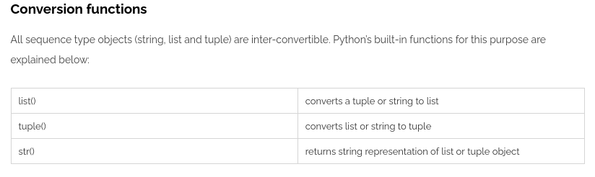
7. Demonstrate the following on dictionary
8. Perform positive indexing, slicing, negative indexing on lists
